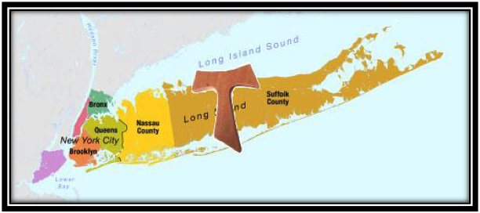

Tau Cross Region

FUN Manual Intentions FORMING THE FORMATORS

The motivating factor that became the momentum for the creation of the FUN Manual was the concern of the Presidency of the International Fraternity that the Order needed to provide worldwide a high-quality and uniform resource for forming the formator so that they could then utilize that information to enhance Initial Formation.
Another concern has been attrition of some members after profession, as well as integration of the Franciscan charism into each professed member’s way of life, Ongoing Formation. Obviously, many members are models of Franciscan living, but other members and fraternities seem to lack the understanding of the nature of the commitment they made. (One of the effort made for this is the dossier for Ongoing Formation that is found at the CIOFS website) In order to be alive in our Franciscan commitment to the fraternity and our faith, we need to be involved in continuous renewal (conversion or penance). So the intention of the manual was to assist, harmonize, and improve the way the Franciscan Vocation, Charism, and Mission of the Order was transmitted to new inquirers and also for already professed members.

One of the materials we received was The Guidelines for Initial Formation (1985), published by NAFRA. The time of Initial Formation was extended from one year of Candidacy, to the addition of Orientation (3 to 6 months), 6 months of Inquiry, and the extension of Candidacy to 18 months, and as a way to help the individual and the fraternity discern if the prospective candidate had a true vocation to the Secular Franciscan Order. During this time several “texts and manuals” were developed to help both the formation team and the candidates prepare for profession and living the life of a Secular Franciscan. However, the quality of formation worldwide varied considerably from one Fraternity to another and from one Region or National Fraternity to another.

So as a result, the “FUN Manual” was designed to remedy these inconsistencies. First, the International Fraternity proposed topics and additional topics were incorporated by our own National Fraternity for inclusion into the plan for initial formation. Many of these topics had been already covered in some of the popular Formation Texts, such as Catch Me a Rainbow Too, by Father Lester Bach, OFM Cap., and Fully Mature in Christ, by Father Benet Fonck, OFM, both of which followed the Rule as the outline for candidacy. However, it was felt that more emphasis was needed on the Franciscan Charism, deepening of our Life of Prayer, living out the meaning of our Profession, and issues of Social Justice. Also in necessity, as a practical issue, much had been written by David and Thérèse Ream ofs, Anne Mulqueen ofs, Teresa Baker ofs, and others, on Discernment and how to best prepare the person in initial formation for profession of a fully committed life as a Franciscan in Fraternity and in their Community, as well as other great information to help the fraternities with the whole formation process. All of this information can be found in the FUN Manual and is designed to provide resources to help us go deeper into our commitment.
The FUN Manual and the accompanying CD are resources that first of all provide comprehensive information for the Formators (Formation Director and those who are assisting the individual(s)) in preparing and celebrating the candidates who are gifting our Fraternity. They also include resources that help the individual and the fraternity to be formed in the Franciscan tradition, as well as to be transformed by the Holy Spirit. The FUN Manual and its accompanying CD are not intended to be used as a Student or Teachers manual OR to be handed over as something that should be read from cover to cover, but rather as a reference manual that one consults and prays over in preparation for lessons for those in initial formation.
As with everything in formation, first we must remember that the Holy Spirit is the primary agent of Formation. The person being formed has the responsibility of their formation, and the Formators are just instruments of the Lord!
May God give you His peace! 8/2015

