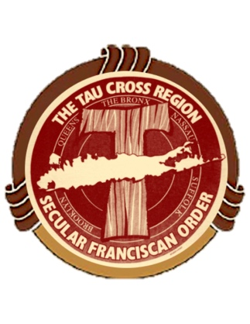
Tau Cross Region
Formation Directors meeting
Cultivating and Forming Intentional Franciscans
October 26, 2019 11:00 AM to 2:00 PM

We are at a Critical time in the Church and in the Life of Our Fraternities! We need you to help remind all members of the Importance of our Vocation and Our Call from GOD!

How often do we recall the words of our Profession?
"I ask to be admitted to profession of the Rule of the Secular Franciscan Order and to make a permanent commitment to the gospel life. The experience during my time of formation has strengthened me in the conviction that the Lord is calling me to observe the holy gospel of Our Lord Jesus Christ by following the footsteps of St. Francis of Assisi."

Who is this for?

Formation Directors or a Representative from Each fraternity is crucial for us all to be united in “Cultivating and Forming Intentional Franciscans”!

Where?
St. Anthony’s High School
275 Wolf Hill Road
South Huntington, New York

Cost:
-$5.00 per person
-Coffee, tea & lunch served
-Bring your own drinks
____________________________________________________
Pre-Registration Form
Fraternity Name________________________________________________
# Attending: ______________________
Who will be Attending? ________________________________________________
Make check payable to: Tau Cross Region
Mail to:
Judy Heffernan, Regional Formation Director
7 Winmar Lane Sayville, NY 11782
Email: jmhblessings@optimum.net
Phone: 631-395-5442 or 516-524-9939

