Renewed in Christ
Why Lent continues to Matter
Presenter Judy Heffernan 4/3/2021

Outline
I want you to LIFT YOUR EYES. And see where you are going? What is God calling you for? What part of the journey are you on? And Why does Lent continue to Matter?
- The 1st two parts took us on a journey through lent with our lord Jesus Christ to the crucifixion. And here we are today waiting in anticipation for the Coming of the Lord. A time of hope and renewal. A time of rejoicing and thanksgiving. A season to continue our walk with the Lord to a place of clarity and understanding.

My Prayer for you: Eph 4:1-3
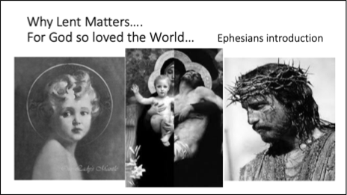
I, then, a prisoner for the Lord, urge you to live in a manner worthy of the call you have received,a 2 with all humility and gentleness, with patience, bearing with one another through love,b 3 striving to preserve the unity of the spirit through the bond of peace:c
- In the introduction to Ephesians
our goals/ corrections/ and language are given to us and God reveals to us our purpose and establishes His Church
Here are the Key steps:
1st we must be in union with Jesus Christ
2nd to be an instrument for making Gods plan of Salvation known to Everyone
3rd Gods loving plan is anchored and shown to us by His son Jesus Christ
4th the Whole of Redemption is rooted in the plan and accomplishment of the triune God
Within the Church that Jesus established
5th the language is spoken
6th In Union as one family
7th with the Gifts given by God
8th with ethical admonition
9th All aspects of human life and relationships are illumined by our Lord Jesus Christ

Putting away our old self and replacing it with our new self
Takes dedication/ recognition/ and goals
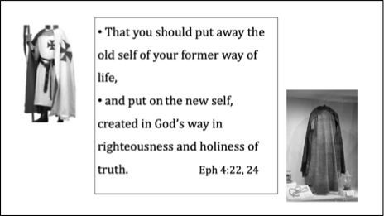
Dedication means - it takes work, perseverance and unity. We must respond and understand that God Reveals Himself and our call gradually to us.
Recognition means - it takes humility and patience with ourselves. to acknowledge our sins. To be honest with ourselves. God knows who we are and what we do and He wants to give us the grace to change and become Holy
Knowing the Goal means – knowing the Truth- Gods truth- Gods Way- Gods Wisdom
anything else can leads us a stray from the Goal God has set for us. A Goal of Holiness. A goal of righteousness and Truth. If we lose our focus, we can be led down the road of perdition. A road that can make us happy for a time but it will not give us Perfect Joy
We are called brothers and sisters of penance to go forth in love and kindness.
- Do we must continually renew our thoughts of penance and sacrifice as a gift?
- a gift of perfect joy
- a gift from our Lord to participate & to share in the plan of salvation
- A gift given to recognize our sinfulness to proclaim, and to respond to Whom God says we are and where He wants to lead us
- A gift of self-denial for the sake of the one that loved us first
- A gift of self-discipline that shields us from the one who wants to destroy and lead us away from the path of renewal and life
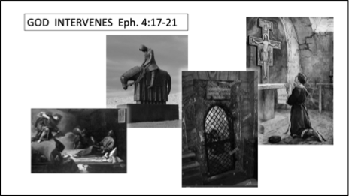
Let’s take a look at Francis’ conversion
The steps which led him to a place of renewal and dedication and discipleship.
We can see more clearly where God has intervened and when and how Francis responded
Francis hopes and dreams of becoming a knight brought him to imprisonment & sickness which led Francis to question himself & ask God what he wanted of him
Took time in prayer and meditation
Francis responded with steps that he could take with the amount of grace he would allow God to give him. For we know that God will grant us all the grace that we need but only as much as we open himself up for Him. Only as much as we are willing to let go, to let go of our old ways and to allow God to replace it with His Truth which leads to Holiness and everlasting Life.
We cannot look at Francis’ holiness and who he became without looking at the steps in which he took to get there. The most difficult times in Francis’ life brought him to a life Illuminated by Christ. How do we respond in times of Trouble?
- What steps are you going to take?
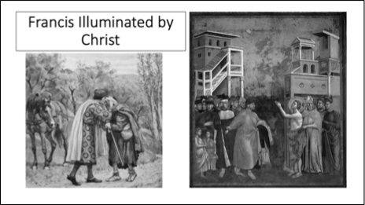
- Are we in union with Christ? are we looking at this time, as the end of our journey, or
as the beginning,
- or are we afraid of letting go of the things that are comfortable, familiar . easy
- Afraid to let go of the attitudes, habits, and thoughts that hold us captive that we think brings us happiness
- Afraid to let go of the relationships that lead us to destruction, disguised as a friend, family member, coworker that blur the vision of How God sees us
- Afraid of letting go of the ideas or dreams of what we thought our life should like and seeing the path that God has set for us.

My challenge for you is this. Take this time of Easter to read Ephesians to journey to Pentecost to a Renewed life in Christ of mutual love

Here are the steps to Remove our old self
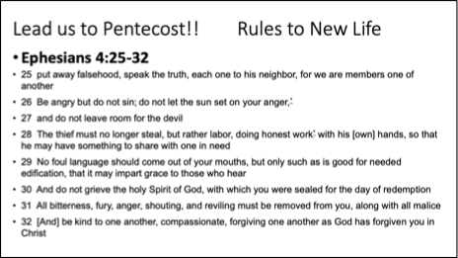
In Ephesian 4: 25-32 it states

25 Therefore, putting away falsehood, speak the truth, each one to his neighbor, for we are members one of another.
26 Be angry but do not sin, do not let the sun set on your anger
27 and do not leave room for the devil.
28 The thief must no longer steal, but rather labor, doing honest work* with his [own] hands, so that he may have something to share with one in need.
29 No foul language should come out of your mouths, but only such as is good for needed edification, that it may impart grace to those who hear.
30 And do not grieve the holy Spirit of God, with which you were sealed for the day of redemption.*
31 All bitterness, fury, anger, shouting, and reviling must be removed from you, along with all malice.^{y}
32 [And] be kind to one another, compassionate, forgiving one another as God has forgiven you in Christ

And go forth with our new self with mutual love and respect for all.
Ephesians 5

Here are Steps of What are renewed self looks like
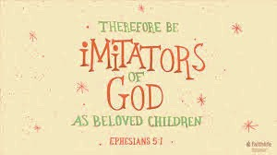
So be imitators of God,* as beloved children,
2and live in love, as Christ loved us and handed himself over for us as a sacrificial offering to God for a fragrant aroma.
3Immorality or any impurity or greed must not even be mentioned among you, as is fitting among holy ones
4no obscenity or silly or suggestive talk, which is out of place, but instead, thanksgiving.
5Be sure of this, that no immoral or impure or greedy person, that is, an idolater, has any inheritance in the kingdom of Christ and of God.
Duty to Live in the Light.
6^{f} Let no one deceive you with empty arguments, for because of these things the wrath of God is coming upon the disobedient.
7So do not be associated with them.
8For you were once darkness, but now you are light in the Lord. Live as children of light,
9for light produces every kind of goodness and righteousness and truth.

